Saved By Grace
Lutheran Church
Christmas 1
Theme: The Presentation of Christ in His Temple
December 28, 2025

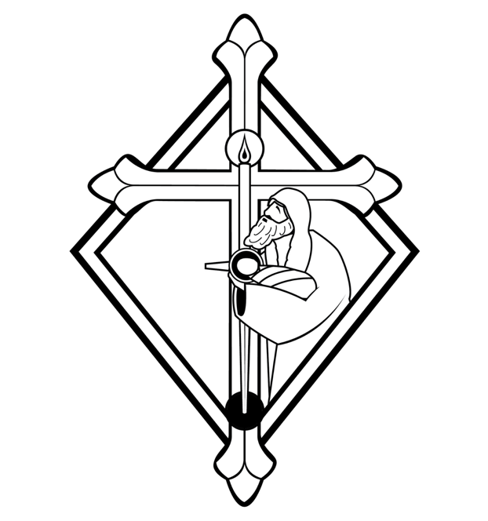

We are a Biblical church giving God’s Word first place in our faith and life. We are a Lutheran church that proclaims forgiveness for all through Jesus Christ. We are a Christian church that gathers to praise God, to be strengthened by His Word, and to reach out to those around us in Christian love.
(Member Congregation of the Evangelical Lutheran Synod)
2010 NE Division Street Gresham, Oregon 97030
Pastor Tim Bartels Church; Organist John Rakos
Phone 503 665-7283
www.savedbygracelutheranchurch.org
Rite II, p. 60

1.The Entrance Hymn: #114, “Angels From the Realms of Glory” (Please stand at the last verse)
2. The Invocation
In the name of the Father and of the Son and of the Holy Spirit ♪ Amen.
3. The Confession and Absolution I
Beloved in the Lord! Let us draw near with a true heart and confess our sins to God, our Father, beseeching Him in the Name of our Lord Jesus Christ to grant us forgiveness.

Our help is in the Name of the Lord. ♪ Who made heav’ n and earth.
I said, I will confess my transgressions to the Lord; ♪ And You forgave the iniquity of my sin.

Let us bow before the Lord and confess our sins. O almighty God, merciful Father, I, a poor, miserable sinner, confess to You all my sins and iniquities with which I have ever offended You and justly deserved Your temporal and eternal punishment. But I am heartily sorry for them, and sincerely repent of them, and I pray You of Your boundless mercy and for the sake of the holy, innocent, bitter sufferings and death of Your beloved Son, Jesus Christ, to be gracious and merciful to me, a poor, sinful being.

Upon this your confession, I by virtue of my office as a called and ordained servant of the word, announce the grace of God to all of you, and in the stead and by the command of our Lord Jesus Christ I forgive you all your sins, in the name of the Father and of the Son † and of the Holy Spirit. May He comfort your heart by His holy Absolution, and strengthen you by His Sacraments, that your joy may be full. Peace be with you! Amen.

4, 5. Introit/Gloria Patri ♪Your testimonies ‘are very sure / holiness adorns Your house O Lord ‘for-ever. Your throne is established ‘from of old /You are ‘everlasting. The Lord reigns, He is clothed ‘with majesty / the Lord is clothed, He has girded ‘Himself with strength. Glory be to the Father, / and to the Son, and to / the Holy Ghost; as it was in the be- / -ginning, is now, and ever shall be: forever- / -more. Amen.
6. The Kyrie Eleison
♪ Lord, have mercy upon us. Christ, have mercy upon us. Lord, have mercy upon us.

7. Gloria in Excelsis, hymn version, #35:1
♪ All glory be to God on high,
Who hath our race befriended!
To us no harm shall now come nigh,
The strife at last is ended.
God showeth His good will to men,
And peace shall reign on earth again:
O thank Him for His goodness!
8. The Salutation
The Lord be with you. ♪ And with your spirit.
9. Collect: Almighty and everlasting God, mercifully direct our actions according to Your gracious will, that in the name of Your beloved Son, we may be made to abound in good works; through Your beloved Son, Jesus Christ, our Lord, who lives and reigns with You and the Holy Spirit, one true God, now and forever. ♪ Amen.
10. The Old Testament Lesson: Genesis 21:1-7 And the Lord visited Sarah as He had said, and the Lord did for Sarah as He had spoken. For Sarah conceived and bore Abraham a son in his old age, at the set time of which God had spoken to him. And Abraham called the name of his son who was born to him—whom Sarah bore to him—Isaac. Then Abraham circumcised his son Isaac when he was eight days old, as God had commanded him. Now Abraham was one hundred years old when his son Isaac was born to him. And Sarah said, “God has made me laugh, and all who hear will laugh with me.” She also said, “Who would have said to Abraham that Sarah would nurse children? For I have borne him a son in his old age.”
11. Gradual:
♪Al-’le-lu-ia! / let the heavens rejoice, and let the earth be glad ‘before the Lord: For he has made known ‘His salvation / Al-’le-lu-ia!
12. Epistle: Galatians 4:1-7 Now I say that the heir, as long as he is a child, does not differ at all from a slave, though he is master of all, but is under guardians and stewards until the time appointed by the father. Even so we, when we were children, were in bondage under the elements of the world. But when the fullness of the time had come, God sent forth His Son, born of a woman, born under the law, to redeem those who were under the law, that we might receive the adoption as sons.
And because you are sons, God has sent forth the Spirit of His Son into your hearts, crying out, “Abba, Father!” Therefore, you are no longer a slave but a son, and if a son, then an heir of God through Christ.
13. Alleluia:
♪Al-’le-lu-ia / the Word was ‘made flesh. And dwelt ‘among us / Al-’le-lu-ia!
14. Gospel: The Holy Gospel for this first Sunday after Christmas is written in the 2nd chapter of the Gospel according to St. Luke, beginning at the 33rd verse. (rise ) ♪ Glory be to You, O Lord! And Joseph and His mother marveled at those things which were spoken of Him. Then Simeon blessed them, and said to Mary His mother, “Behold, this Child is destined for the fall and rising of many in Israel, and for a sign which will be spoken against (yes, a sword will pierce through your own soul also), that the thoughts of many hearts may be revealed.”
Now there was one, Anna, a prophetess, the daughter of Phanuel, of the tribe of Asher. She was of a great age, and had lived with a husband seven years from her virginity; and this woman was a widow of about eighty-four years, who did not depart from the temple, but served God with fastings and prayers night and day. And coming in that instant she gave thanks to the Lord, and spoke of Him to all those who looked for redemption in Jerusalem.
So when they had performed all things according to the law of the Lord, they returned to Galilee, to their own city, Nazareth. And the Child grew and became strong in spirit, filled with wisdom; and the grace of God was upon Him. ♪ Praise be to You, O Christ!
15. The Nicene Creed, p. 69 I believe in one God, the Father Almighty, maker of heaven and earth and of all things visible and invisible. And in one Lord Jesus Christ, the only-begotten Son of God, begotten of his Father before all worlds, God of God, Light of Light, very God of very God, begotten, not made, being of one substance with the Father, by whom all things were made; who for us men and for our salvation came down from heaven and was incarnate by the Holy Spirit of the virgin Mary and was made man; and was crucified also for us under Pontius Pilate. He suffered and was buried. And the third day he rose again according to the Scriptures and ascended into heaven and is seated at the right hand of the Father. And he shall come again with glory to judge both the living and the dead, whose kingdom shall have no end. And I believe in the Holy Spirit, the Lord and Giver of life, Who proceeds from the Father and the Son, who with the Father and the Son together is worshiped and glorified, who spoke by the prophets. And I believe in one holy Christian and apostolic Church, I acknowledge one Baptism for the remission of sins, and I look for the resurrection of the dead and the life † of the world to come. Amen.
16. The Chief Hymn: #165, “Let the Earth Now Praise the Lord”
17. Sermon Text/Theme: Genesis 17:1-7, “God Keeps His Word”
18a. Hymn: #124:1,2,13, “From Heaven Above to Earth I Come”
18b. Offering: As the offering is brought forward, the congregation sings Hymn #105:1
♪ O rich the gifts Thou bring’st us. Thyself made poor and weak;
O love beyond expression, That thus can sinners seek!
For this, O Lord, will we Our joyous tribute to bring Thee,
And glad Hosannas sing Thee, And ever grateful be.

18b. Offering
19. The Prayer of the Church
Communion Hymn: #115:1, 12-15, “All My Heart Sings and Rejoices”
Communion Exhortation (see insert)
20. The Preface The Lord be with you. ♪ And with your spirit. Lift up your hearts. ♪ We lift them up unto the Lord. Let us give thanks to the Lord, our God. ♪ It is good and right so to do.
21. Proper Preface and Sanctus:
It is good, right, and salutary that we should at all times and in all places give thanks to You, holy Lord, almighty Father, everlasting God; (the pastor prays the seasonal prayer…) therefore with angels and archangels and all the company of heaven we laud and magnify Your glorious name, evermore praising You and saying: ♪ Holy, holy, holy, Lord God of Sabaoth; Heav’n and earth are full of Your glory. Hosanna, hosanna, hosanna in the highest. Blessed is He, blessed is He, blessed is He who comes in the Name of the Lord. Hosanna, hosanna, hosanna in the highest.
23. The Lord’s Prayer (sung in unison)
♪ Our Father, who art in heaven, Hallowed be Thy name, Thy kingdom come, Thy will be done on earth as it is in heaven. Give us this day our daily bread; And forgive us our trespasses, as we forgive those who trespass against us; And lead us not into temptation, But deliver us from evil. For Thine is the kingdom and the pow’r and the glory forever and ever. Amen
24. The Words of Institution
Our Lord Jesus Christ, the same night in which He was betrayed, took bread and when He had given thanks, He broke it and gave it to His disciples saying: “Take, eat; this is My + body, which is given for you. This do in remembrance of Me.” In the same way also He took the cup after supper, gave thanks, and gave it to them saying: “Drink of it all of you; this cup is the New Testament in My + blood, which is shed for you and for many, for the remission of sins. This do as often as you drink it, in remembrance of Me.
25. The Pax Domini The peace of the Lord be with you always. ♪ Amen
26. Agnus Dei
♪ O Christ, the Lamb of God, You take away the sin of the world, have mercy upon us. O Christ, the Lamb of God. You take away the sin of the world, have mercy upon us. O Christ, the Lamb of God, You take away the sin of the world, grant us Your peace. Amen.
28. The Nunc Dimittis
♪ Lord, now You let Your servant depart in peace according to Your word. For my eyes have seen Your salvation, which You have prepared before the face of all people, a Light to lighten the Gentiles and the glory of Your people Israel. Glory be to the Father and to the Son and to the Holy Ghost; as it was in the beginning, is now, and ever shall be, forevermore. Amen.
29. The Collect of Thanksgiving I
O give thanks unto the Lord, for He is good. ♪ And His mercy endures forever.

We give thanks to You, almighty God, that You have refreshed us through these salutary gifts, and we implore You that of Your mercy You would strengthen us through them in faith toward You and in fervent love toward one another; through Jesus Christ, Your Son, our Lord, who lives and reigns with You and the Holy Spirit, one true God, now and forever. ♪ Amen.
31. The Salutation
The Lord be with you.♪ And with your spirit.
32. The Benedicamus
Let us bless the Lord. ♪ Thanks be to God!
33.The Benediction
The Lord bless you and keep you. The Lord make His face shine upon you and be gracious unto you. The Lord lift up His countenance upon you and give + you peace.
♪ Amen, amen, amen.
34. The Closing Hymn: #134 “Let Us All with Gladsome Voice”

